

**University of Prince Mugrin**

**College of Computer and Cyber Sciences**

**Computer Science Department**

**CS211**

**CS351**

**Fundamentals of Database Systems**

**project**

**Project name:**

**Blood and Organs Donation System**

**Group members:**

**Salwa Shamma 4010405**

**Samah Shamma 4010403**

**Sana Shamma 4010404**

**Satha Faraj 4010378**

**Section:**

**L01**

**Instructure:**

**Dr. Ftoon Hamza Kedwan**

**Fall 2021**

DONOR Table:

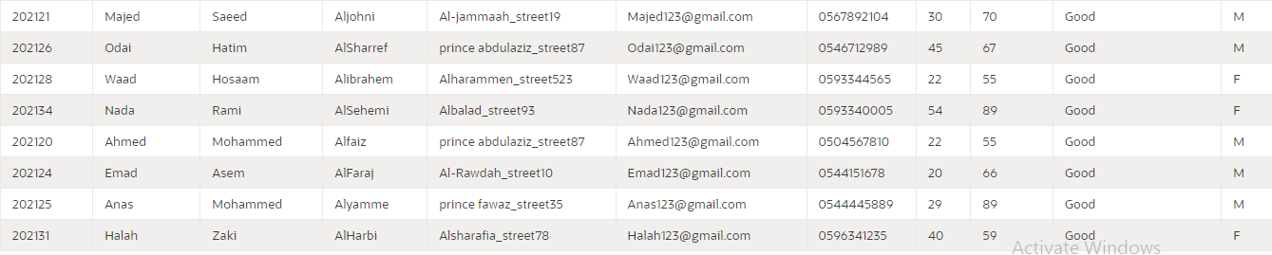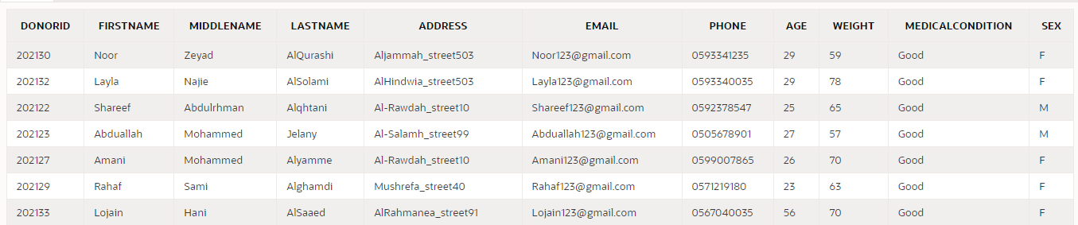

Donor relation has 11 attributes that are Donorid, Firstname, Middlename, Lastname, Address, Email Phone, Age, Weight, MedicalCondition, and SEX. Donorid is a primary key in this relation to distinguish between donors and to facilitate the process of donates in blood bank. ( There is a relationship between donor and blood bank which is donates in to keep track how much the donor participated of the amount of blood on specific types)and organs inventory ( there is a relationship between donor and organs inventory which is gives to keep track organ quantity for each organ which is donated by donor).

DOCTOR Table:

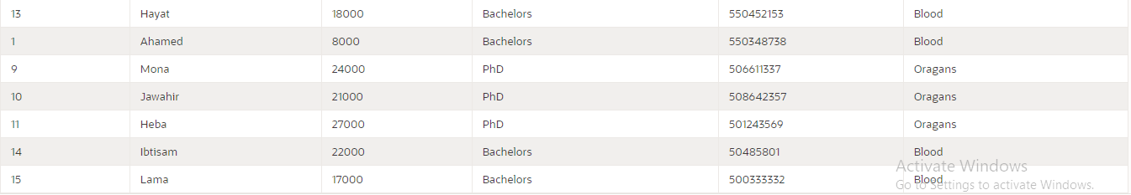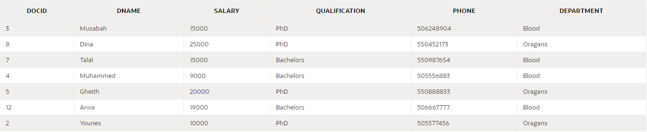

Doctor relation has 6 attributes which are: Docid, Dname, Salary, Qualification, Phone, and Department. Docid is a primary key in this relation to distinguish between doctors and to facilitate the following process: assigning appointments with patients (doctor treats with the patient by giving the appointment). In addition, requests organs ( doctors deals with organ inventory to show which organ the doctor need for give it to the patient)and request blood(there is a relationship between doctor and blood bank which is order to keep track how much the doctor has taken from the blood bank).

PATIENT Table:

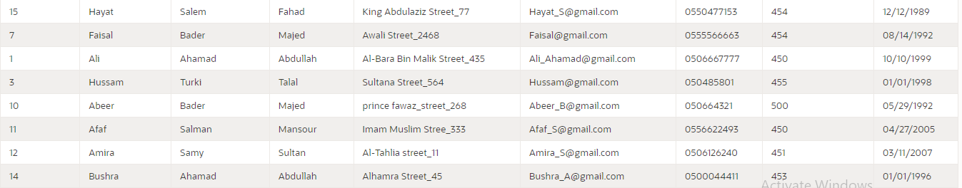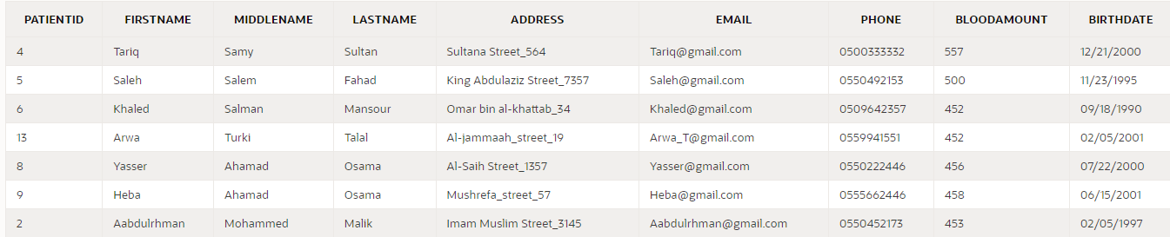

The patient table contains 9 attributes which are patient ID we chose it as a primary key because it is the only attribute that help us to differentiate between panties. Also we have first name, middle name, last name email, address, phone, blood amount, birth date, also it has a relationship with treats table to show the relationship between the doctors and their patients (doctors treat patients).

BLOODBANK Table:

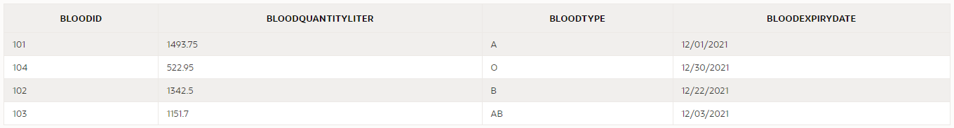

Bloodbank relation has four attributes: BloodID, bloodQuantityLiter, bloodtype and bloodExpiryDate. BloodID is a primary key in this relation to distinguish between blood groups and to facilitate the process of requesting and donating. Moreover, the bloodbank has a relationship with Doner relation to show the relationship between them (Where the blood donated by the donor will be stored in the blood bank). In addition, blood bank relation has a relationship with doctor relation (Where the doctor needs different amounts of different types of blood types to give them to patients who need them).

ORGANSINVENTORY Table:

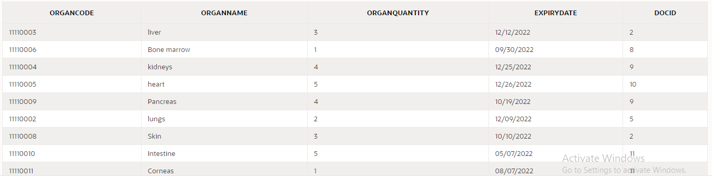

The organs inventory table contains 5 attributes which are organ name, organ quantity and organ code which is the primary key it help us to differentiate between organs ex: if they have same name and expiry date we can differentiate by using the code. In addition, we have expiry date, doctor id which is a foreign key from Doctor table it help us connecting doctors who conduct the process of transplantation to organ inventory table , also it has a relationship with doctor table To explain the process of organ transplantation by doctors. Moreover, it has a relationship with gives table that shows the relationship between donor and organs inventory (donors give organs to the organ inventory).

DONATESIN Table:

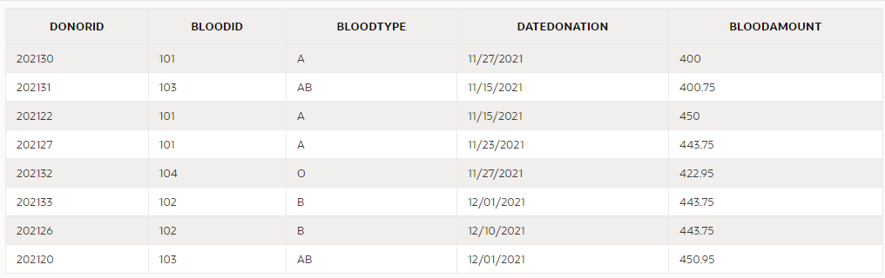

Donation relationship has two attributes that are the blood amount and the date donation. This relationship highlights the process between donors with blood bank. The purpose of this relationship is that keep track of this procedure of blood donation and storing the blood (the donor donates in the blood bank). In addition, it includes two foreign key, which are Donor ID to check the ability of the donor to donate and Blood ID to track the source of blood and knowing the donor if there are any upcoming issues.

GIVES Table:

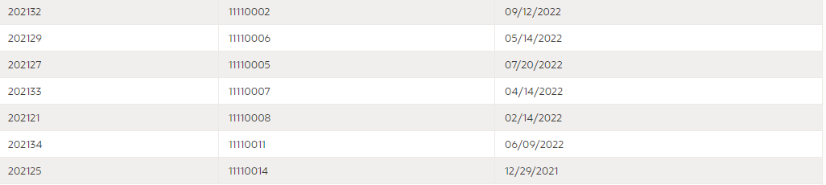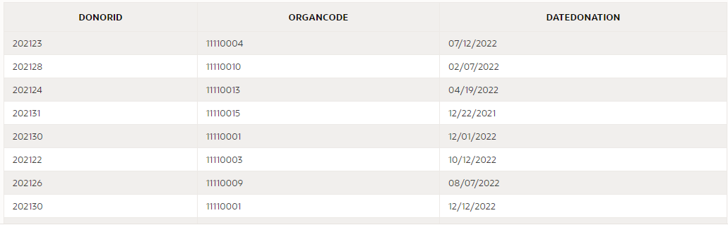

Gives relationship has one attribute, which is Date donation, this relationship shows the process between the donors with organs inventory, the purpose of this relationship is that keep track of this procedure of donation and storing (donors give organs to the organ inventory). Moreover, this relationship includes two foreign keys, which are Donor ID to check the ability of the donor to donate, plus organ code to track the source of organ and knowing the donor if there are any upcoming issues.

TREATS Table:

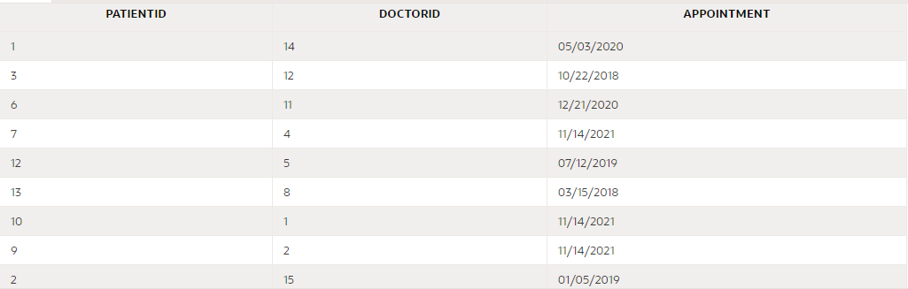

Treats relationship has three attributes that are PATIENTID, DOCTORID, and APPOINTMENT, this relation to assign each doctor with patients and give them appointments. This relationship has two foreign keys Patientid and Doctorid (they are considered to be primary keys on this relation) to facilitate the process of assigning.

Orders Table:

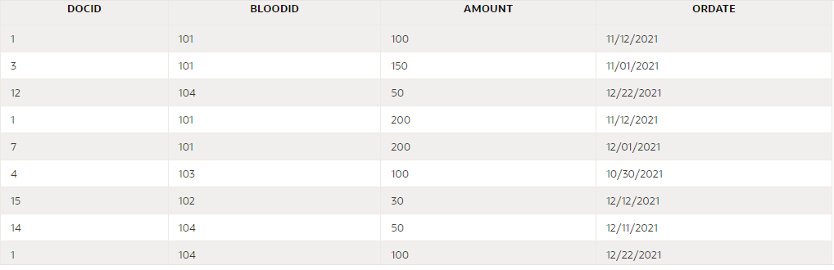

Orders relationship has 4 attributes which are: DOCID, BLOODID, AMOUNT, and ORDATE. This relation to keeping track of the amount of blood in the bloodbank and knowing how much the doctor took from the blood bank with type and date of order. There are two foreign keys Docid and Bloodid to facilitate the process of withdrawing from the blood bank.